# Chapter 7: Input and Output Design and Result Analysis [PO5]

This chapter presents the input and output design of the AI-Enhanced Healthcare and Wellness Management System. The system interface is designed to provide intuitive user experience for patients, doctors, and administrators. Each feature includes input forms for data collection and output displays for presenting processed information.

## a1. Home Page and Navigation Module

### System Input Design

The home page serves as the primary entry point for all users. Input elements include navigation menu selections, search queries for doctors or services, and quick access buttons for key features. Users can interact with the hero section to explore system capabilities.

### System Output Design

The output displays a responsive landing page with featured services, doctor specializations, health tips, and call-to-action sections. The navigation bar provides access to all system modules. The footer section contains contact information, quick links, and social media connections.

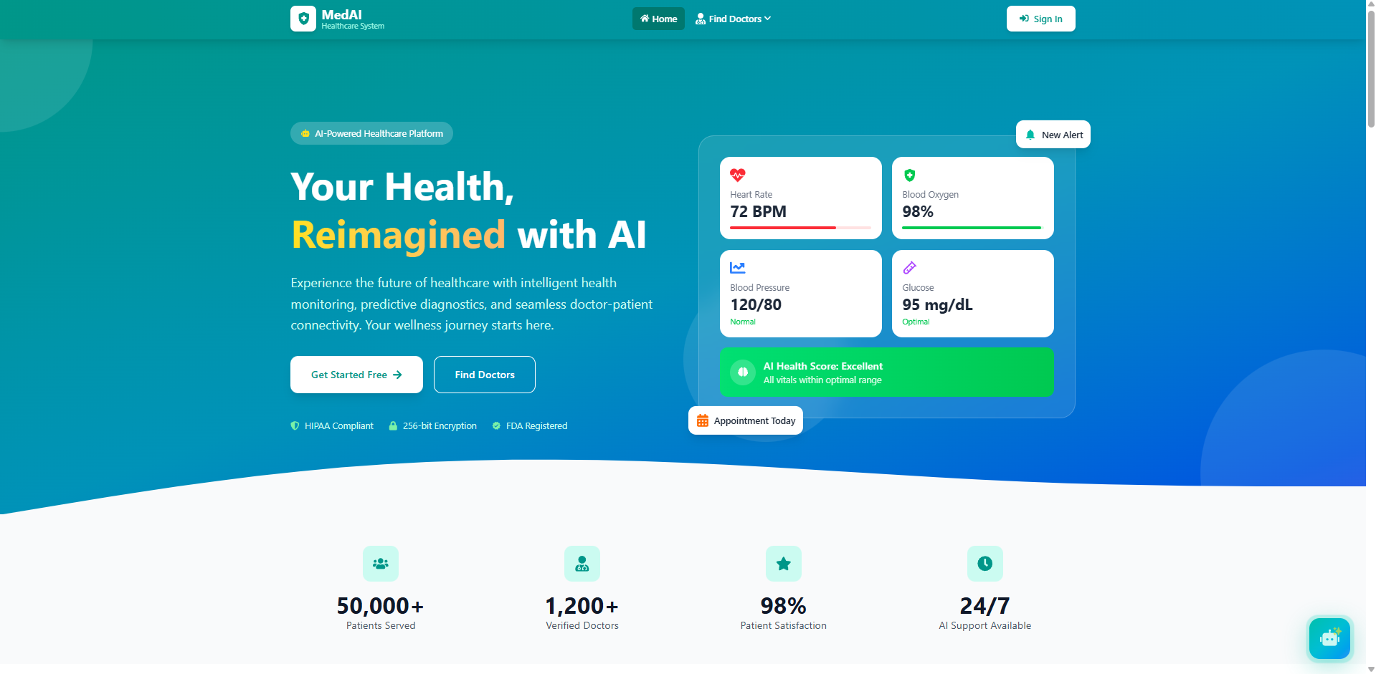

*Figure 7.1: Home Page - Hero Section*

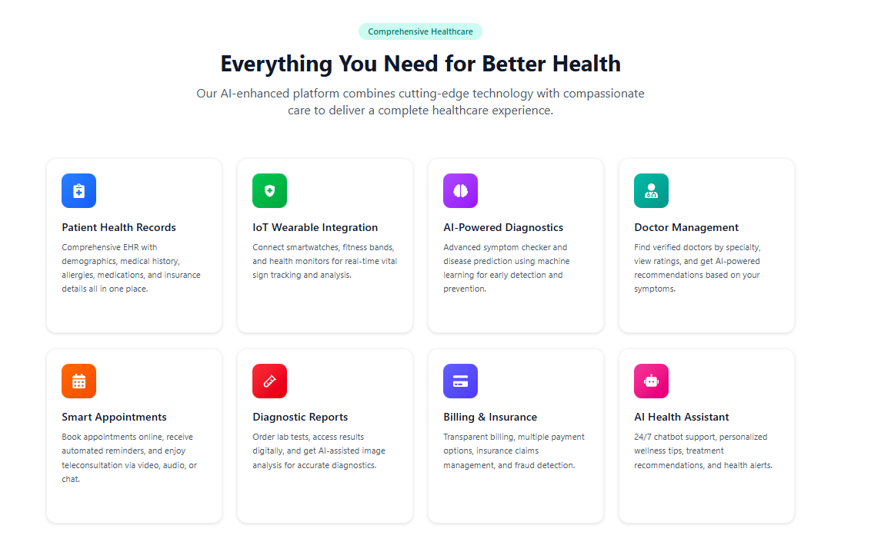

*Figure 7.2: Home Page - Services Section*

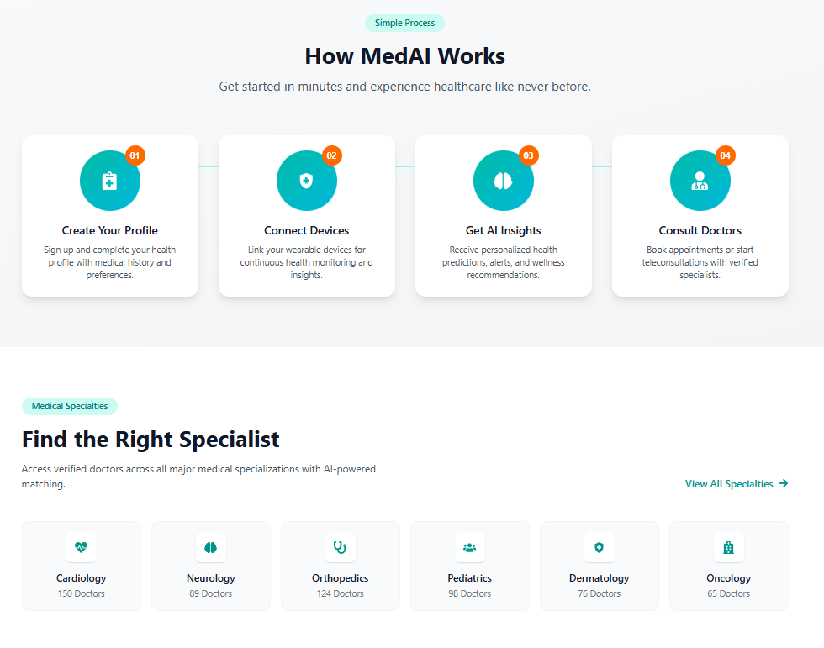

*Figure 7.3: Home Page - Features Section*

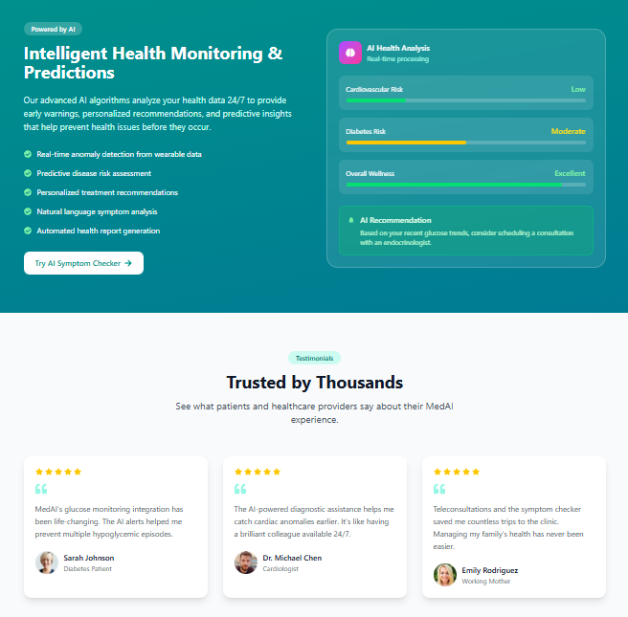

*Figure 7.4: Home Page - Doctor Specializations*

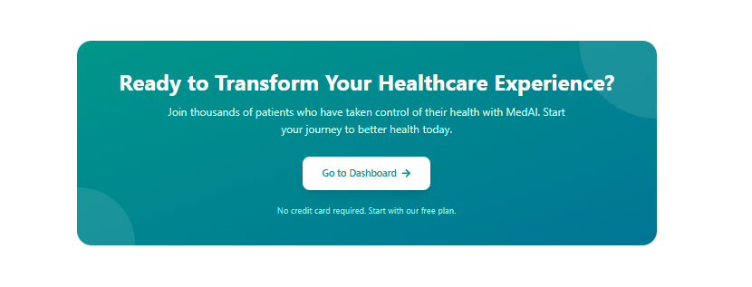

*Figure 7.5: Home Page - Health Tips Section*

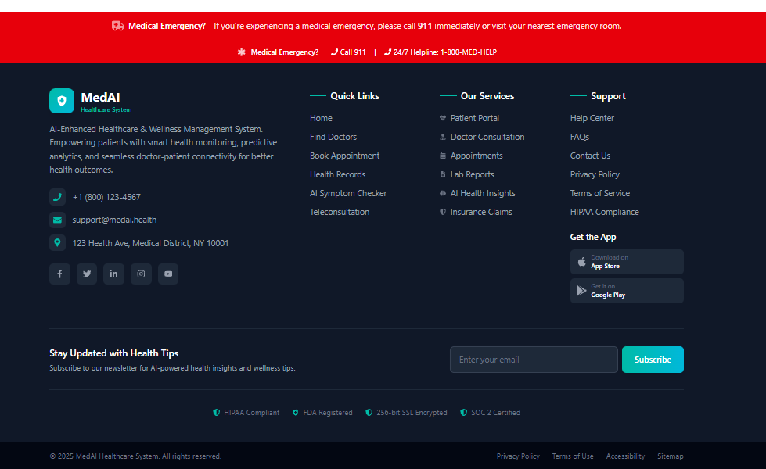

*Figure 7.6: Footer Section*

## a2. User Authentication Module

### System Input Design

The authentication module collects user credentials for secure system access. The Sign In form requires email address and password inputs with validation. The Sign Up form collects comprehensive registration data including full name, email, password, confirm password, phone number, and user role selection (Patient/Doctor).

### System Output Design

Upon successful authentication, users are redirected to their respective dashboards based on role. Error messages are displayed for invalid credentials. Password strength indicators and validation messages guide users during registration. Social login options provide alternative authentication methods.

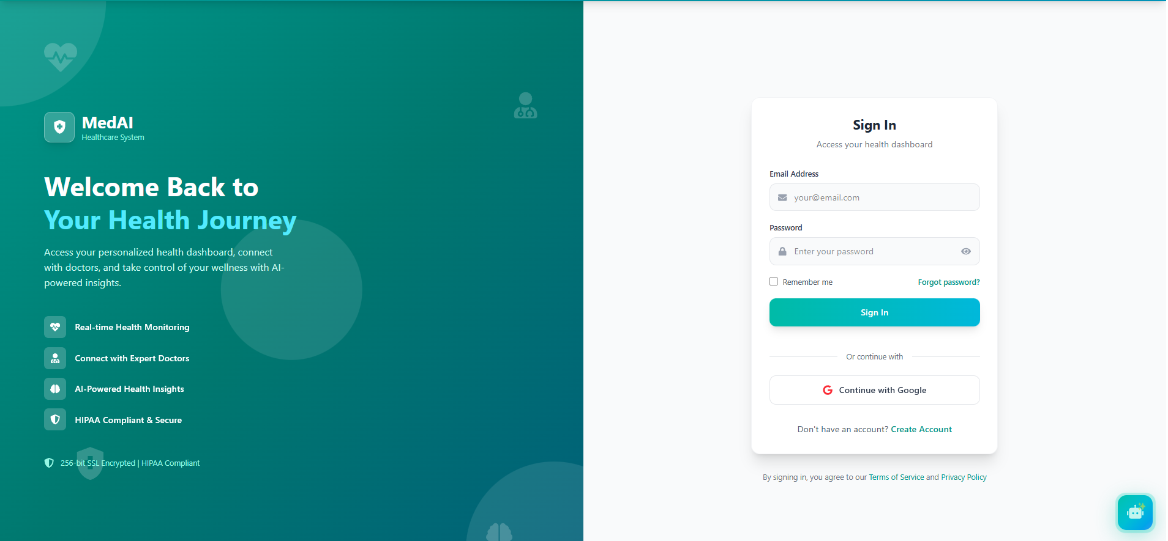

*Figure 7.7: Sign In Page*

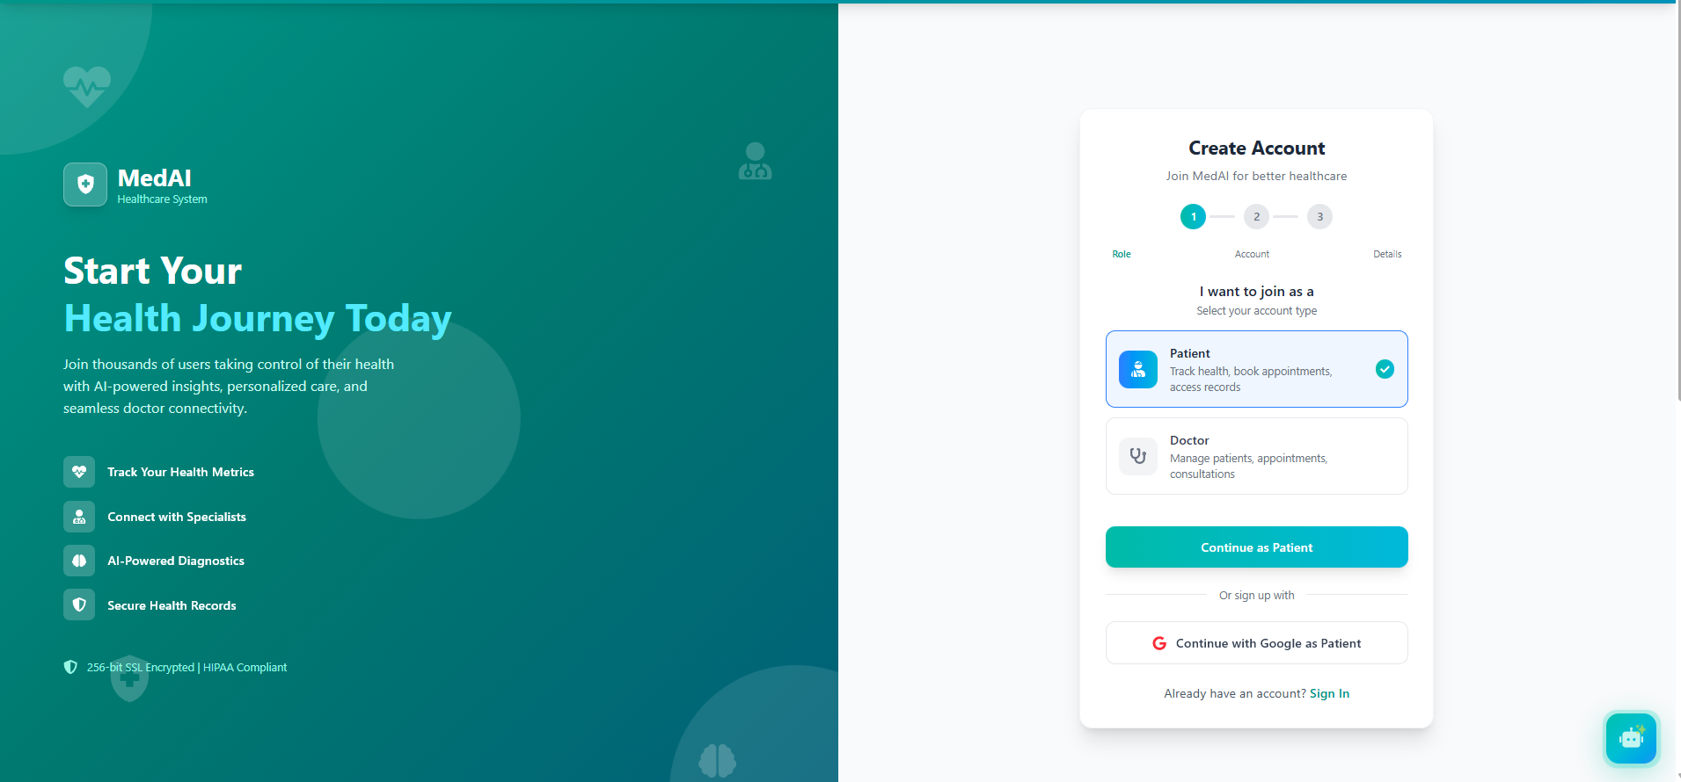

*Figure 7.8: Sign Up Page*

## a3. AI Chat System Module

### System Input Design

The AI Chat System accepts natural language text input from users through a chat interface. Users can type health-related queries, symptoms, or general questions. The input field supports multi-line text entry with send button activation.

### System Output Design

The AI-powered chatbot processes user queries using Natural Language Processing (NLP) and generates contextual responses. The output displays in a conversational format with clear distinction between user messages and AI responses. The system provides 24/7 instant support for health inquiries, appointment guidance, and general assistance.

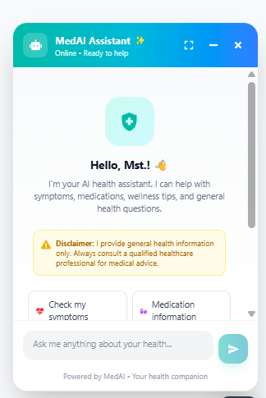

*Figure 7.9: AI Chat Interface - Mobile View*

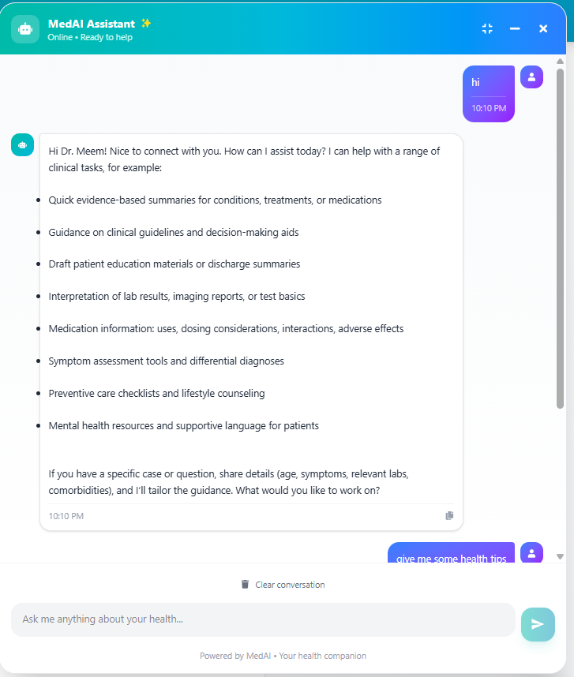

*Figure 7.10: AI Chat System - Conversation Output*

## a4. Find Doctors and Appointment Booking Module

### System Input Design

The doctor search module accepts multiple input parameters including specialization selection, location filters, availability preferences, and search keywords. The appointment booking form collects preferred date, time slot, consultation type (in-person/video), and reason for visit.

### System Output Design

The system displays a filtered list of doctors matching search criteria with profile cards showing name, specialization, experience, ratings, and availability status. Doctor profile pages present detailed information including qualifications, consultation fees, available slots, and patient reviews. Appointment confirmation displays booking details with date, time, and consultation instructions.

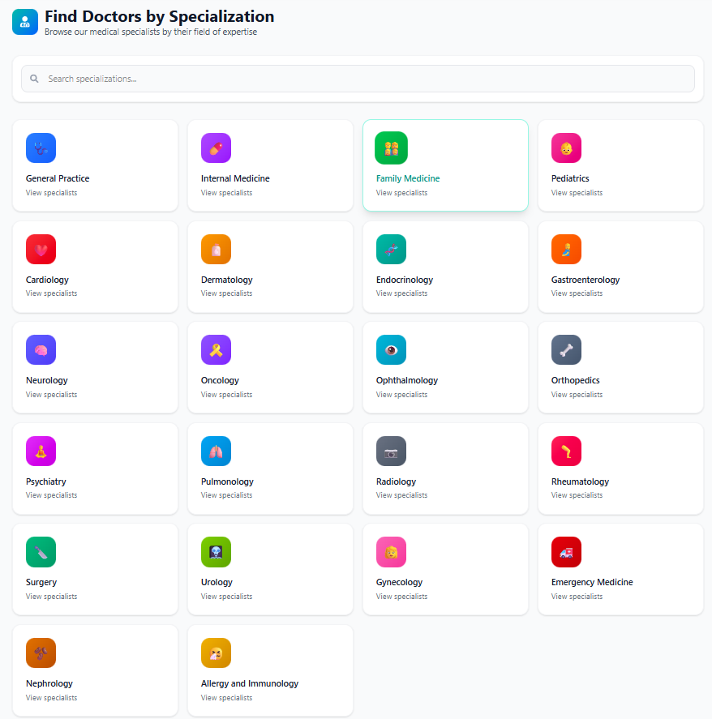

*Figure 7.11: Find Doctors by Specialization*

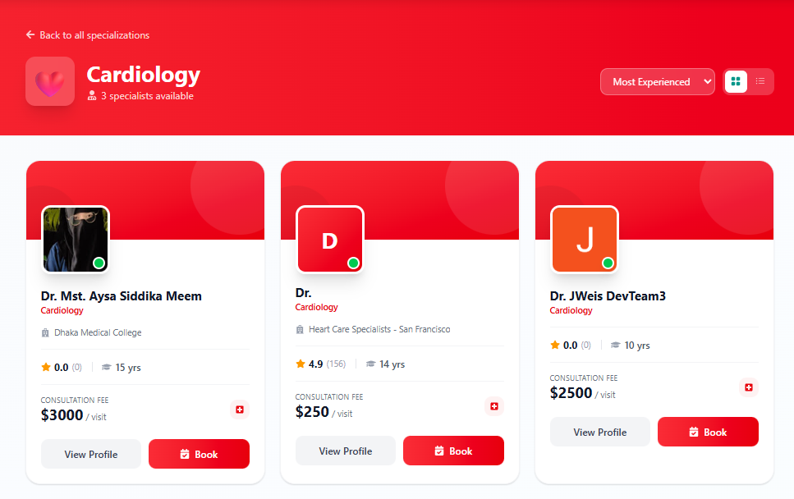

*Figure 7.12: Doctor Search Results*

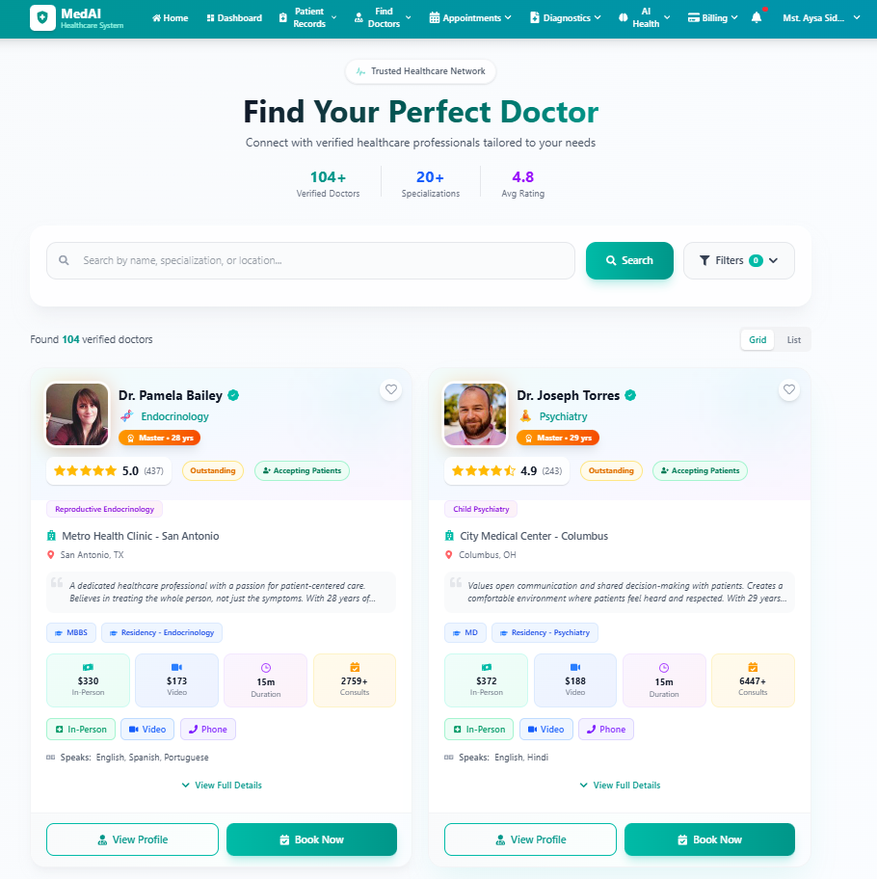

*Figure 7.13: All Doctors Listing Page*

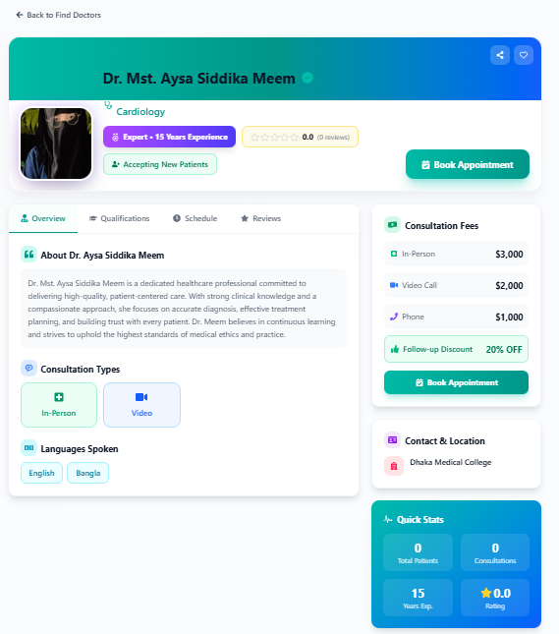

*Figure 7.14: Doctor Profile Page*

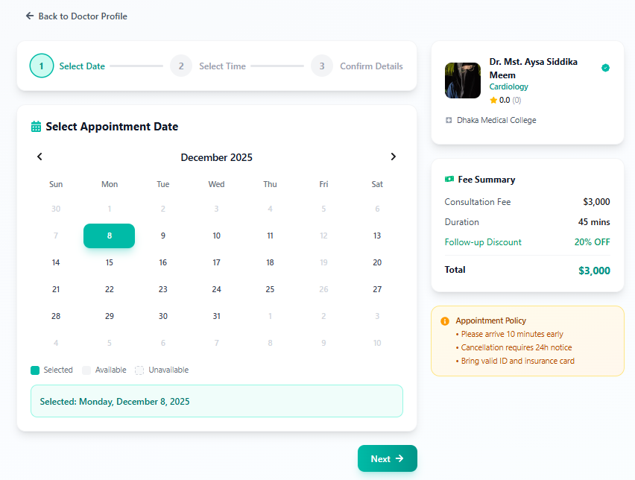

*Figure 7.15: Appointment Booking - Date Selection*

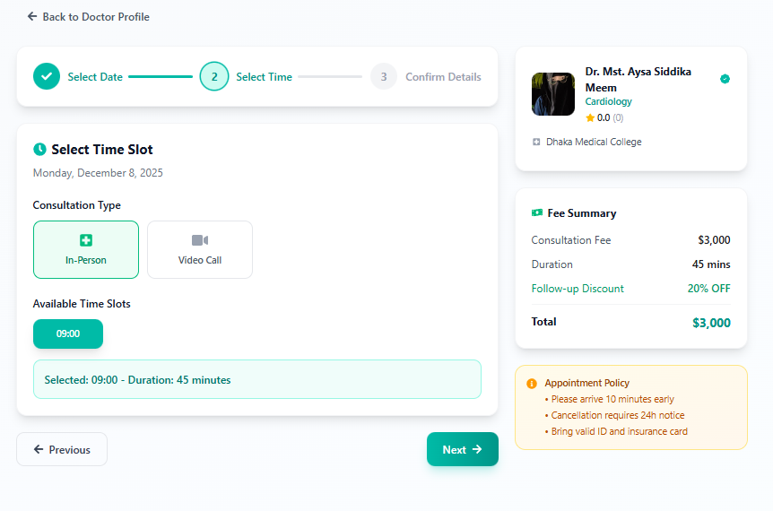

*Figure 7.16: Appointment Booking - Time Slot Selection*

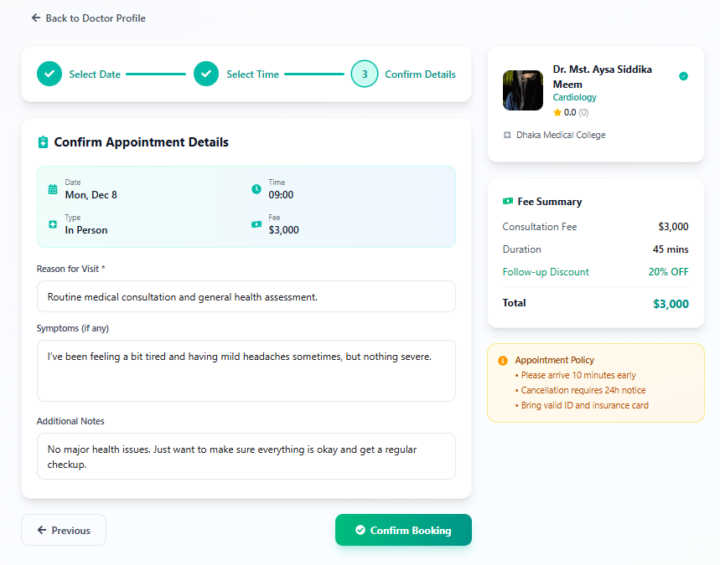

*Figure 7.17: Appointment Booking - Confirmation*

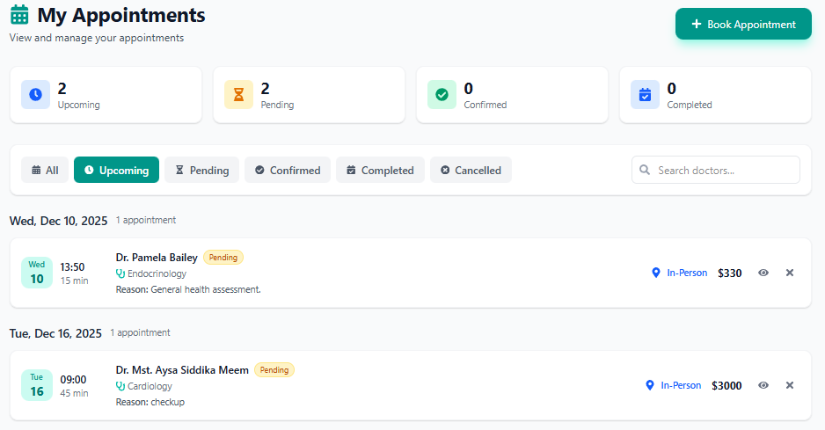

*Figure 7.18: Appointment Success Message*

## a5. Billing and Payment Module

### System Input Design

The billing module accepts payment method selection, card details for online payments, billing address, and insurance information if applicable. Users can select from multiple payment options including credit/debit cards, digital wallets, and insurance claims.

### System Output Design

The system displays itemized billing statements with consultation fees, additional charges, applicable discounts, and total amount. Payment confirmation includes transaction ID, payment status, and downloadable receipt. The billing history shows all past transactions with filtering options.

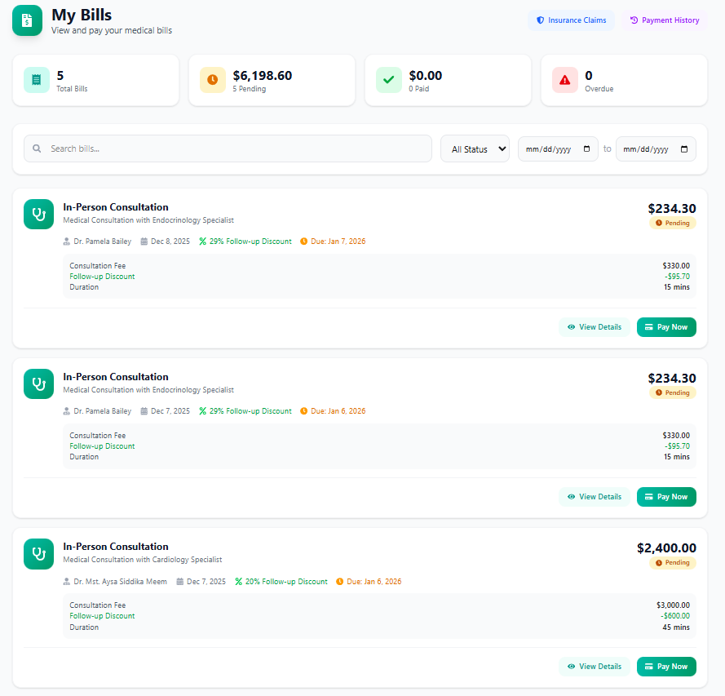

*Figure 7.19: Billing and Payment Page*

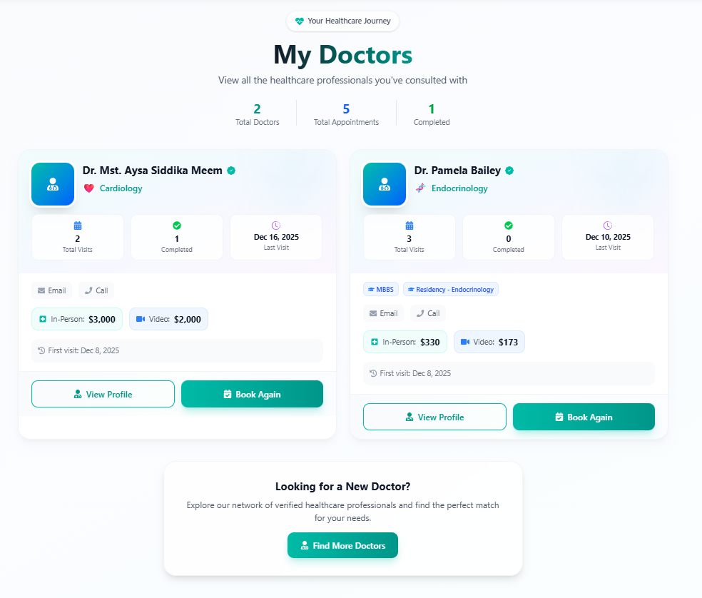

*Figure 7.20: My Doctor - Assigned Doctor Details*

## a6. Patient Dashboard and Health Metrics Module

### System Input Design

The patient dashboard accepts health metric inputs including blood pressure readings, heart rate, weight, blood glucose levels, and other vital signs. Users can manually enter data or sync from IoT wearable devices. Date range filters allow viewing historical health data.

### System Output Design

The dashboard displays comprehensive health overview with visual charts and graphs showing vital sign trends over time. Quick access cards show upcoming appointments, recent prescriptions, and pending lab results. Health metrics are presented with normal range indicators and alerts for abnormal values.

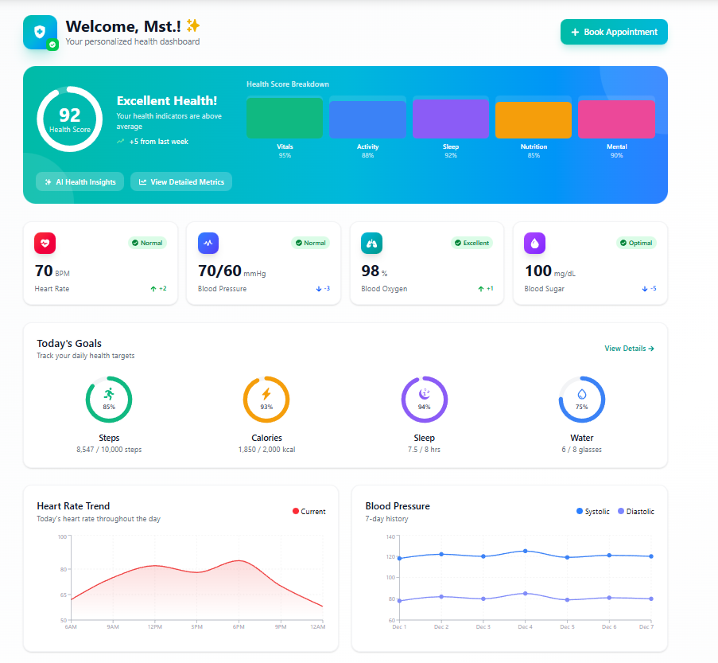

*Figure 7.21: Patient Dashboard - Overview*

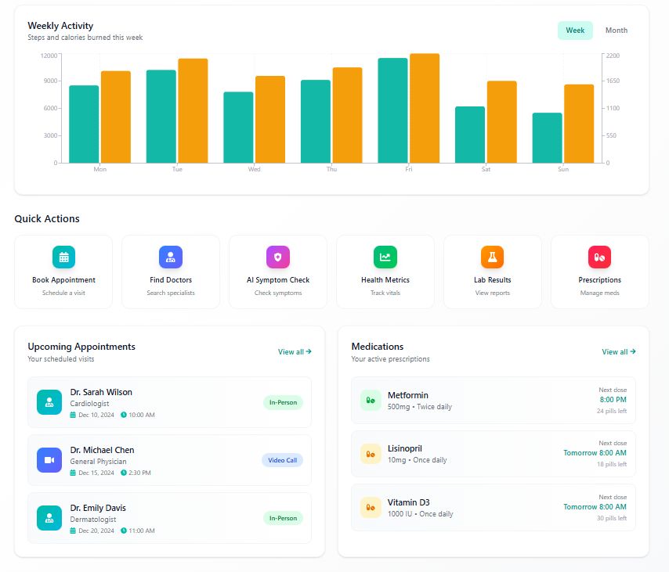

*Figure 7.22: Patient Dashboard - Appointments Section*

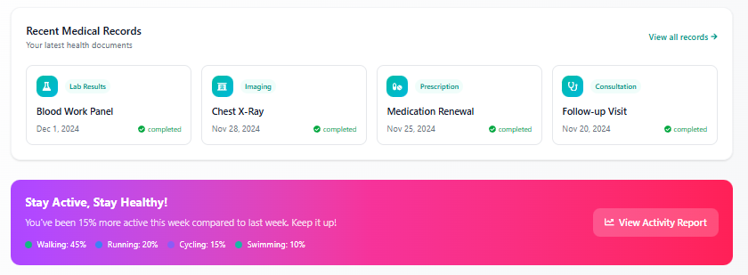

*Figure 7.23: Patient Dashboard - Quick Actions*

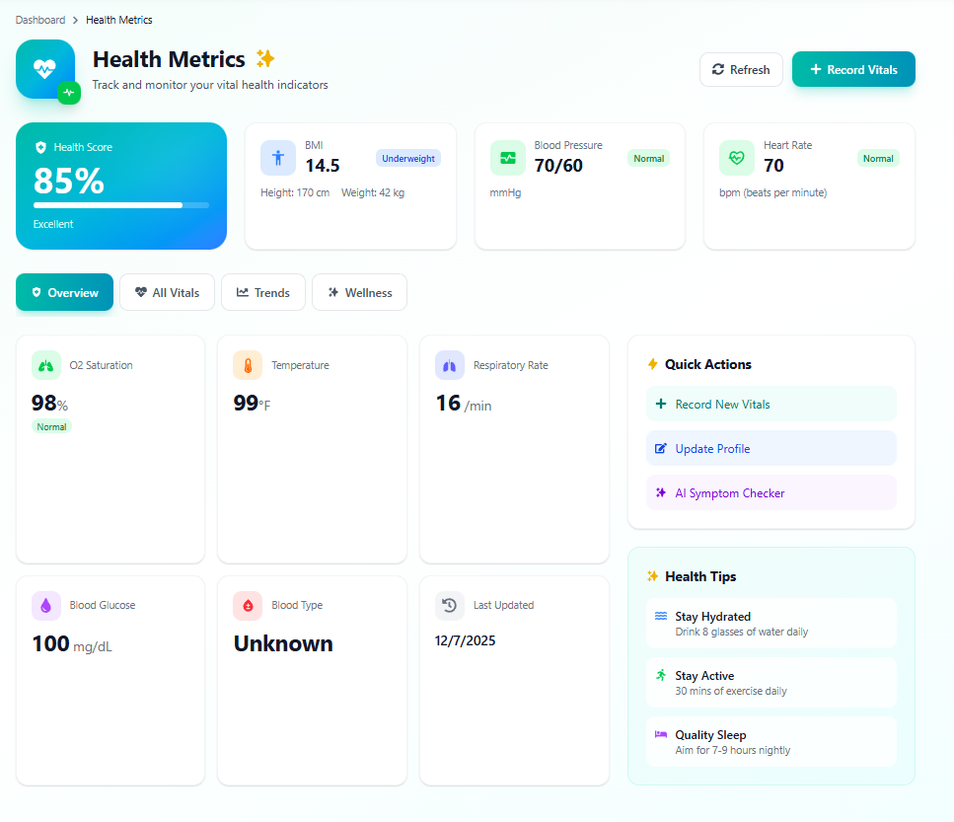

*Figure 7.24: Health Metrics - Vital Signs Chart*

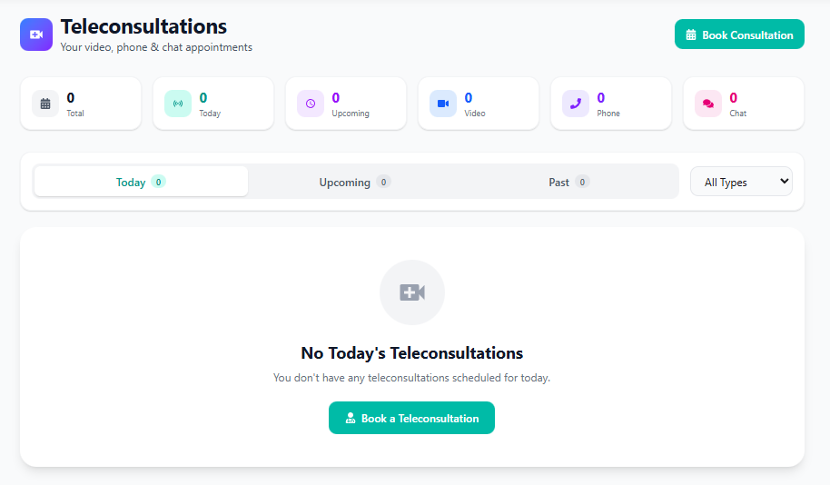

*Figure 7.25: Health Metrics - Data Entry Form*

## a7. Diagnosis and Lab Tests Module

### System Input Design

The diagnosis module accepts doctor-prescribed test orders with test type selection, priority level, and special instructions. Patients can upload external lab reports in PDF or image format. The system accepts lab result data entry from laboratory technicians with test values and reference ranges.

### System Output Design

The system displays pending and completed lab tests with status tracking. Lab results are presented with test values, normal ranges, and visual indicators for abnormal results. Patients can view and download lab reports. Historical test data enables trend analysis for chronic condition monitoring.

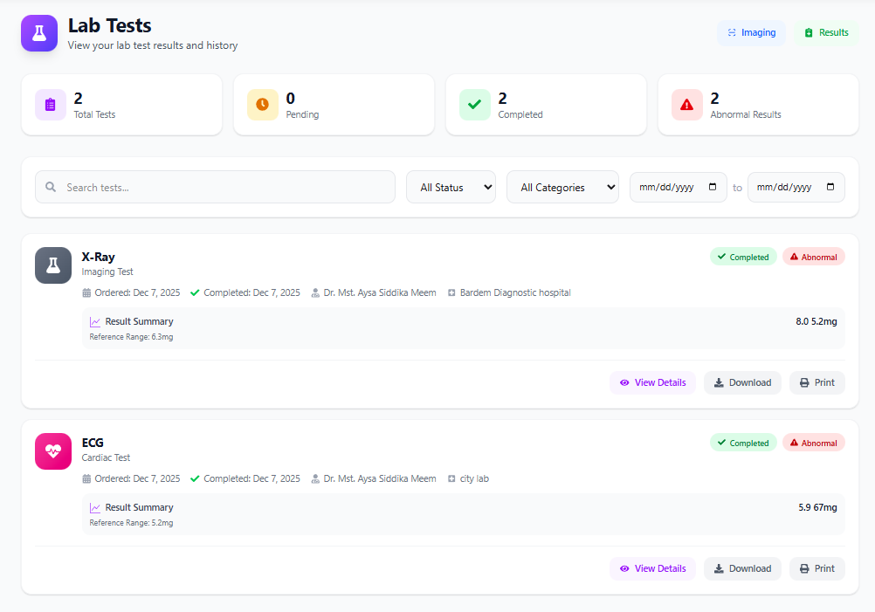

*Figure 7.26: Lab Tests - Patient View*

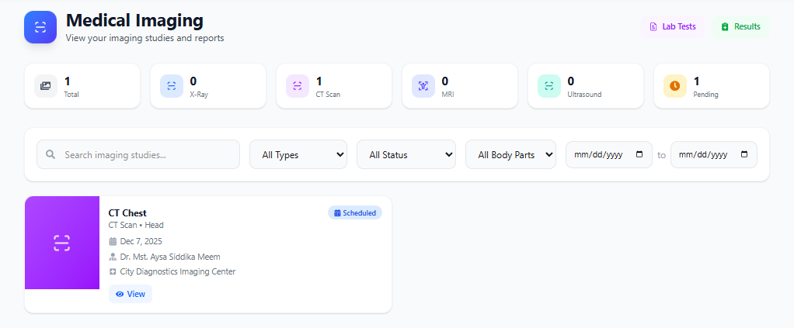

*Figure 7.27: Lab Test Order Details*

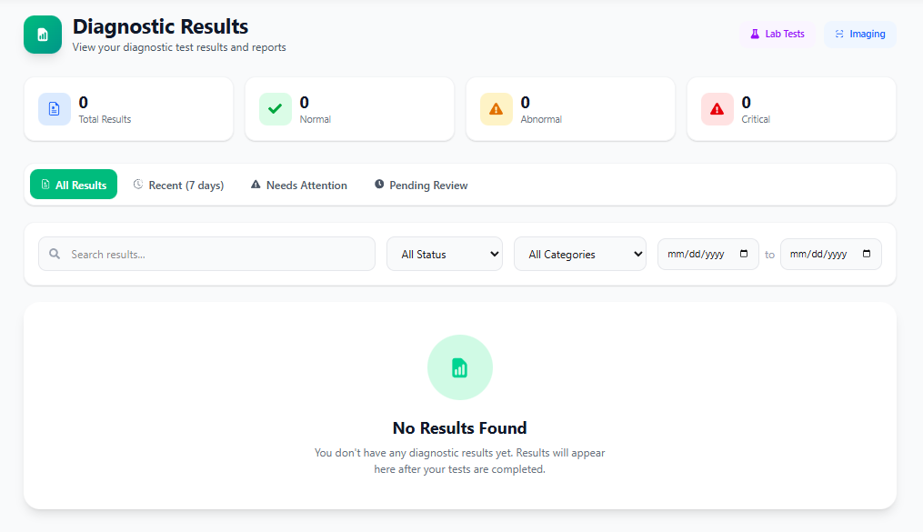

*Figure 7.28: Lab Results Display*

## a8. AI Symptom Checker and Health Prediction Module

### System Input Design

The AI Symptom Checker accepts detailed symptom descriptions through text input and symptom selection checkboxes. Users provide symptom duration, severity level, and associated conditions. The Health Prediction module accepts health parameters including age, weight, blood pressure, cholesterol levels, and lifestyle factors for risk assessment.

### System Output Design

The AI engine analyzes input symptoms using machine learning algorithms and displays possible conditions with probability scores. Recommendations include suggested specialist consultations, immediate care advice, and preventive measures. Health Prediction outputs include disease risk percentages, contributing factors analysis, and personalized health recommendations with visual risk indicators.

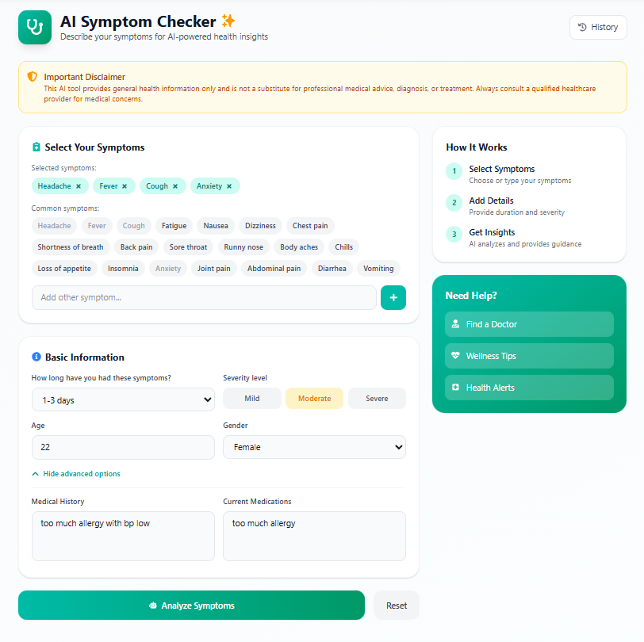

*Figure 7.29: AI Symptom Checker - Input Form*

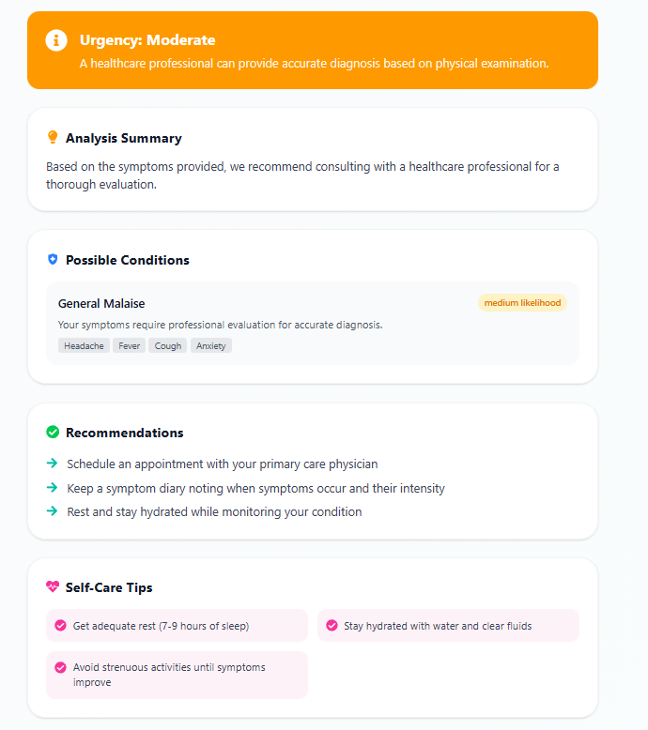

*Figure 7.30: AI Symptom Checker - Analysis Results*

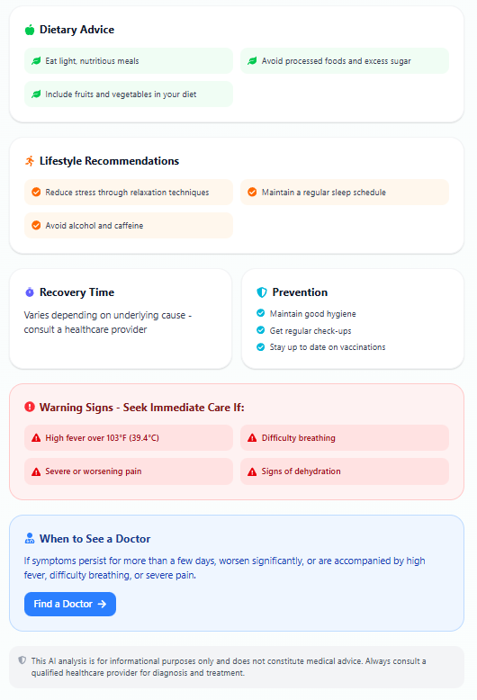

*Figure 7.31: AI Symptom Checker - Detailed Recommendations*

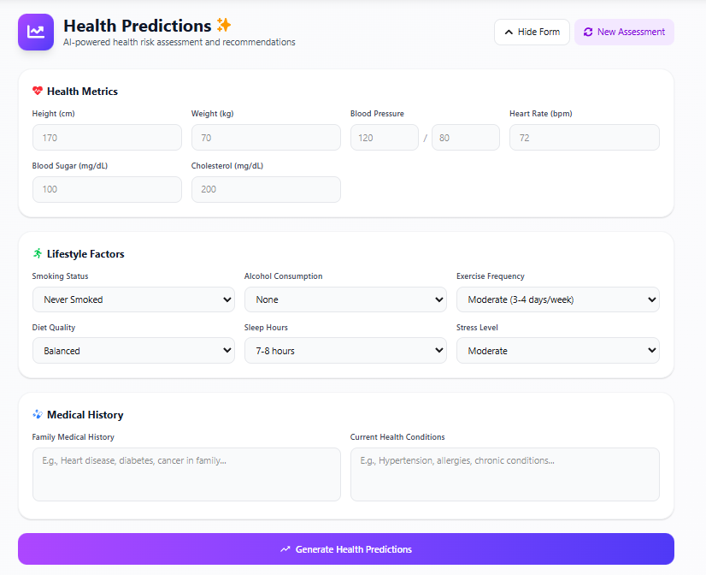

*Figure 7.32: Health Prediction - Input Parameters*

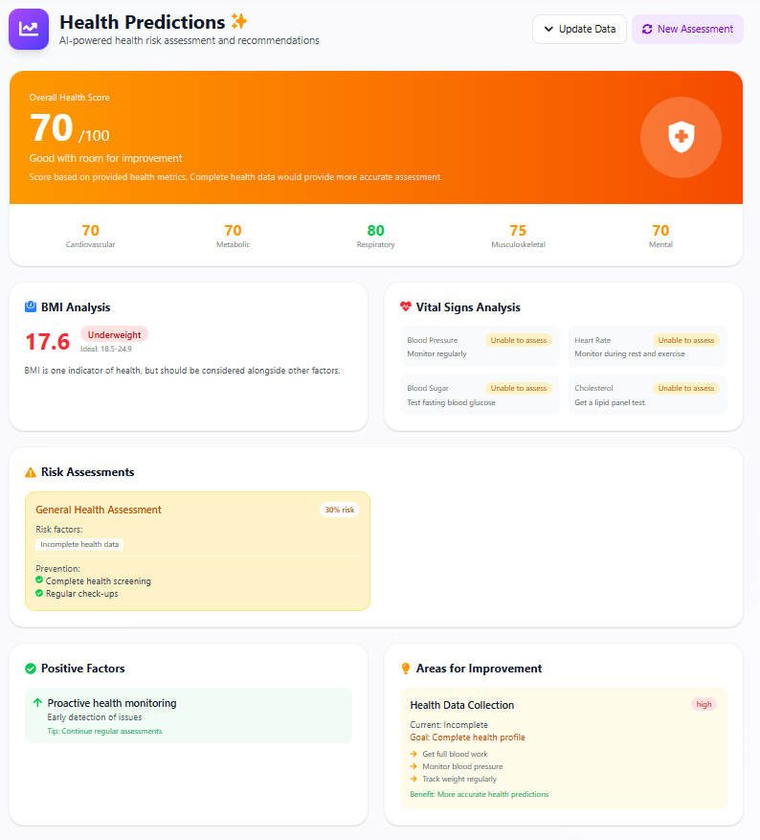

*Figure 7.33: Health Prediction - Risk Analysis Output*

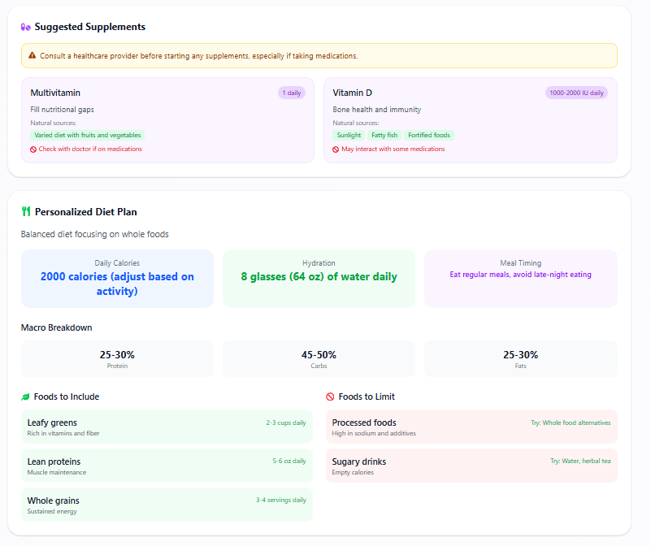

*Figure 7.34: Health Prediction - Detailed Results*

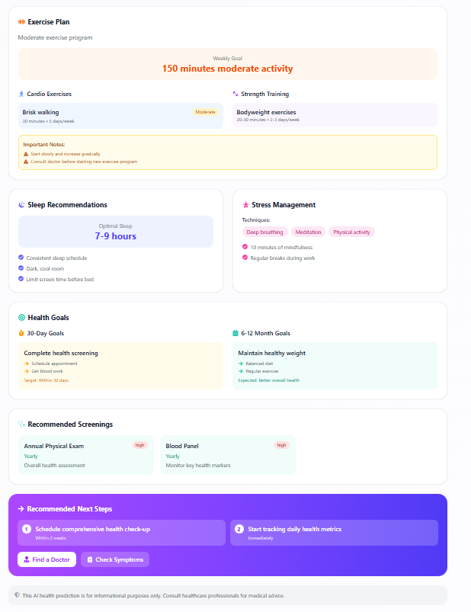

*Figure 7.35: Health Prediction - Recommendations*

## a9. Doctor Dashboard and Appointment Management Module

### System Input Design

The doctor dashboard accepts schedule management inputs including availability slots, consultation duration, and break times. During patient consultations, doctors input diagnosis notes, prescription details, treatment plans, and follow-up recommendations. The system accepts patient record updates and lab test orders.

### System Output Design

The dashboard displays daily appointment schedule, patient queue, and consultation statistics. Patient profiles show complete medical history, previous visits, prescriptions, and lab results. The system outputs e-prescriptions, medical certificates, and referral letters. Analytics display consultation counts, patient demographics, and revenue summaries.

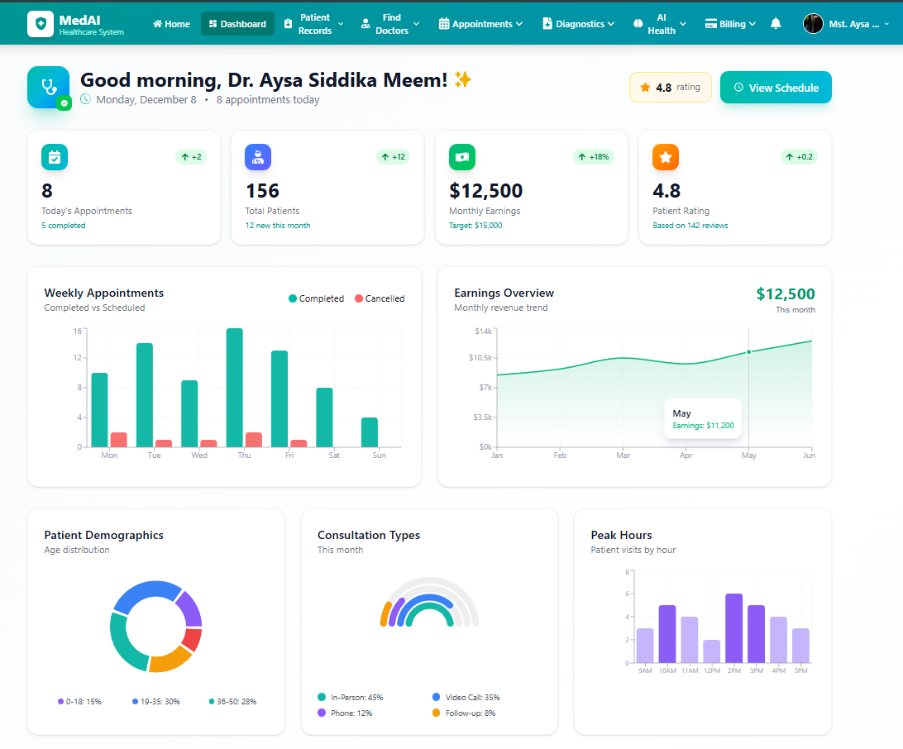

*Figure 7.36: Doctor Dashboard - Overview*

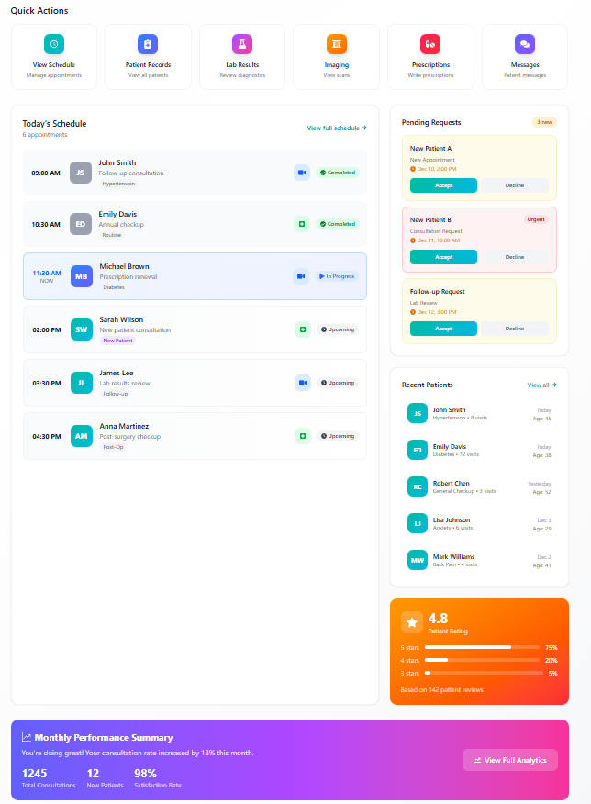

*Figure 7.37: Doctor Dashboard - Detailed View*

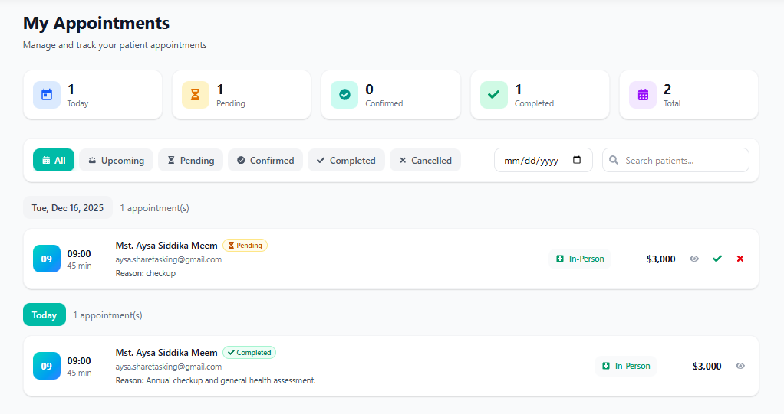

*Figure 7.38: Appointment Management - Patient List*

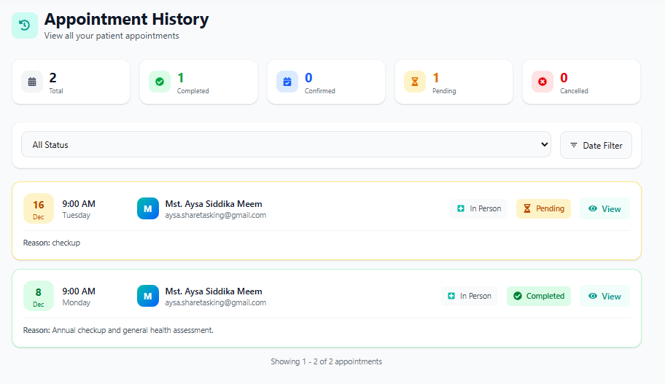

*Figure 7.39: Appointment Details View*

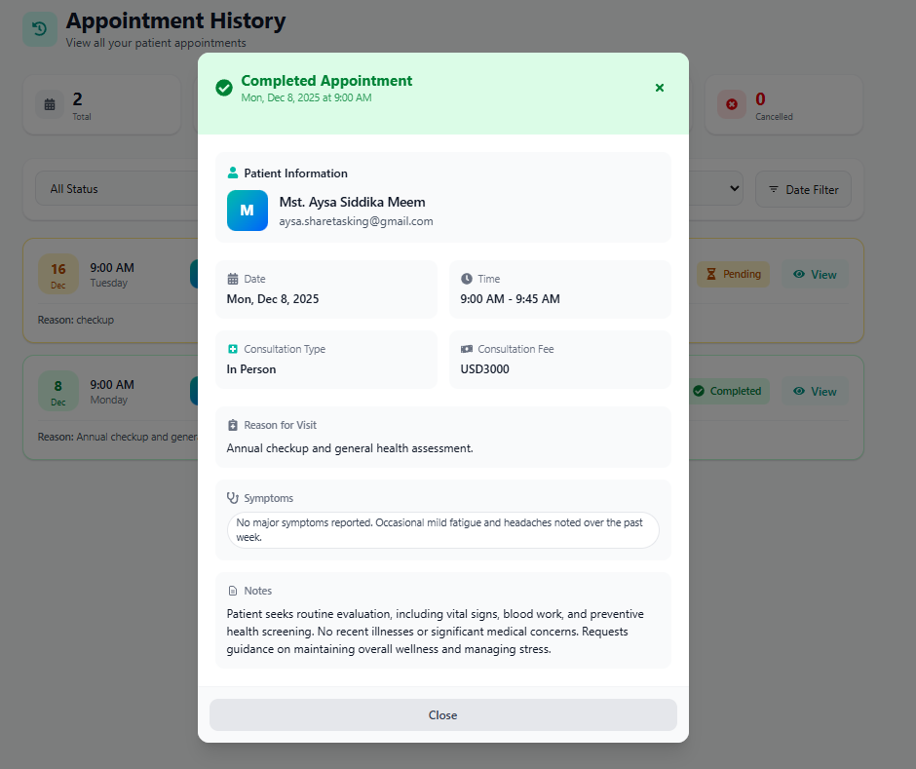

*Figure 7.40: Patient Consultation Interface*

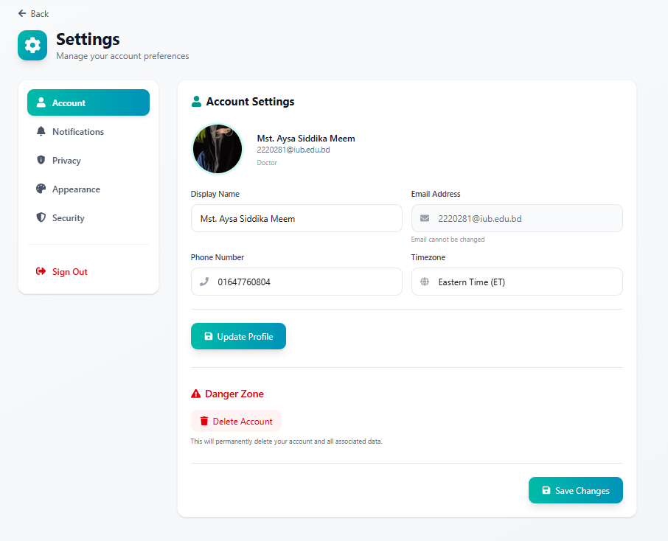

*Figure 7.41: Doctor Settings - Profile Management*

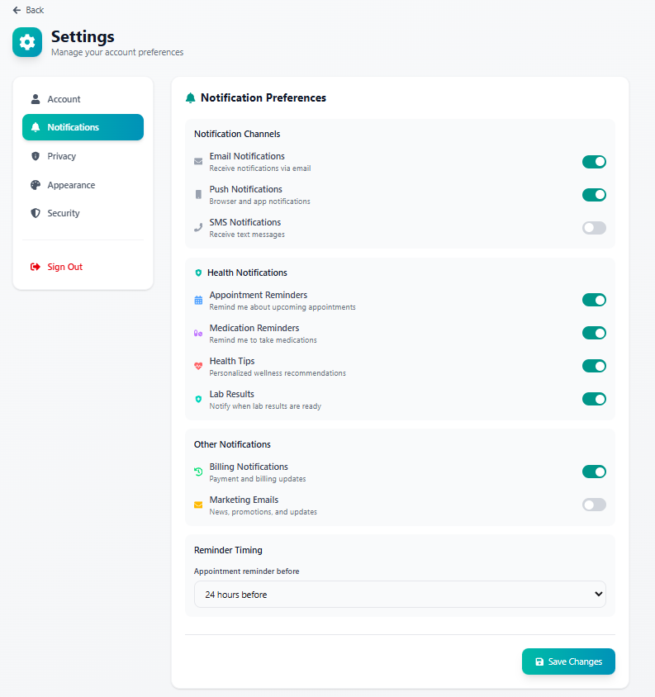

*Figure 7.42: Doctor Settings - Schedule Configuration*

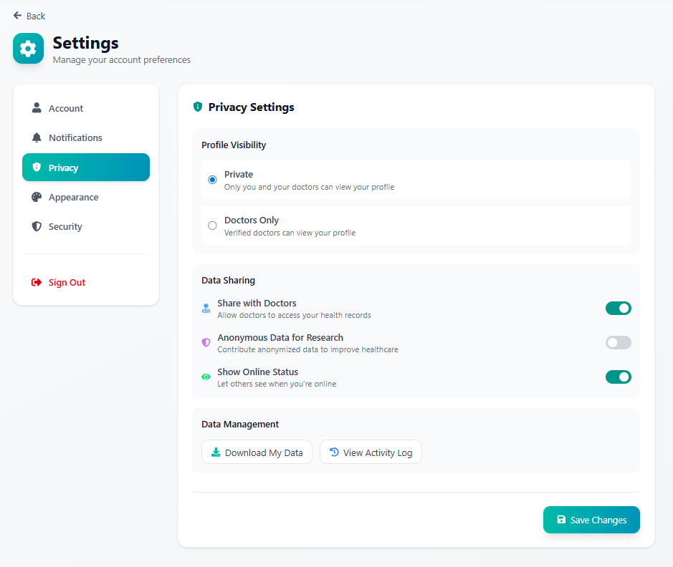

*Figure 7.43: Doctor Settings - Notification Preferences*

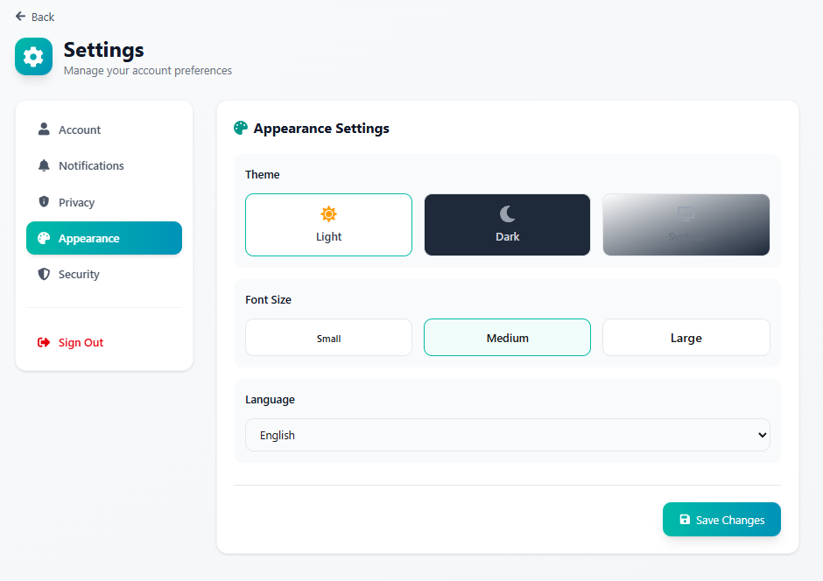

*Figure 7.44: Doctor Settings - Privacy Settings*

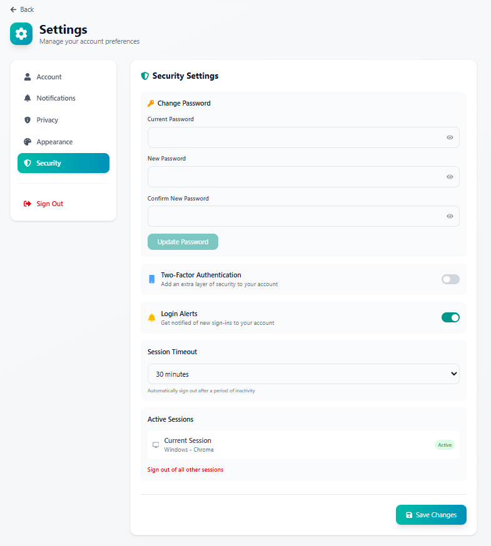

*Figure 7.45: Doctor Settings - Security Options*

## a10. Admin Dashboard and System Management Module

### System Input Design

The admin dashboard accepts system configuration inputs including user role management, permission settings, and system parameters. Admin functions include doctor verification document review, user account actions (approve/suspend/delete), and content management inputs. System settings accept notification templates, payment gateway configurations, and security policies.

### System Output Design

The admin dashboard displays comprehensive system analytics including total users, active doctors, appointments processed, and revenue statistics. User management interface shows complete user listings with role, status, and action options. Doctor verification queue displays pending applications with submitted credentials. System logs and audit trails provide activity monitoring. Reports generation outputs statistical summaries and data exports.

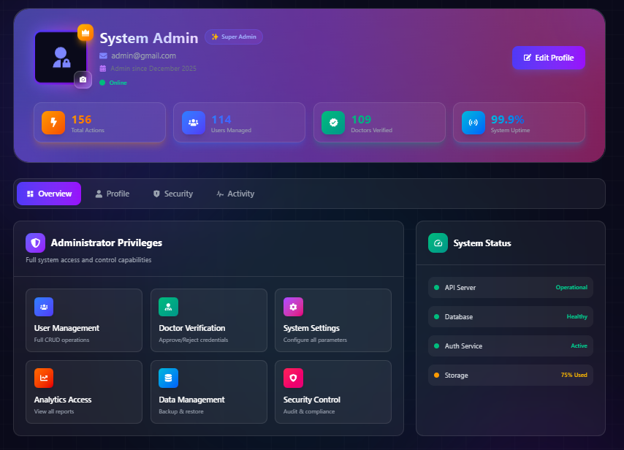

*Figure 7.46: Admin Profile Page*

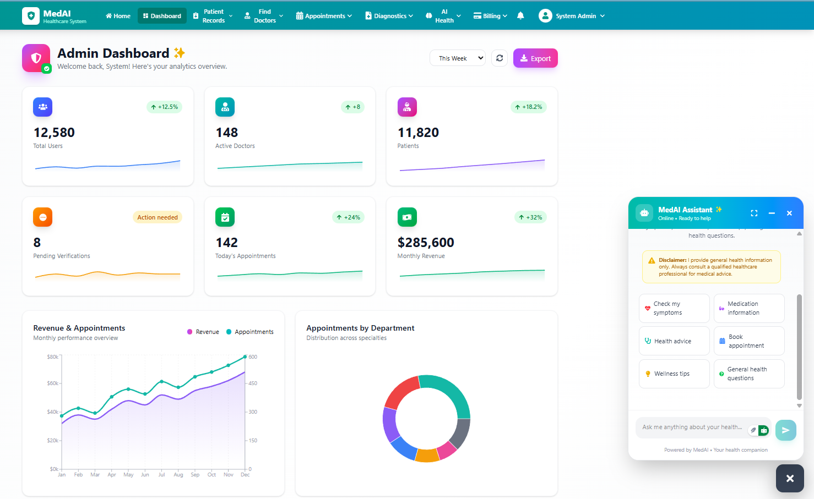

*Figure 7.47: Admin Dashboard - Statistics Overview*

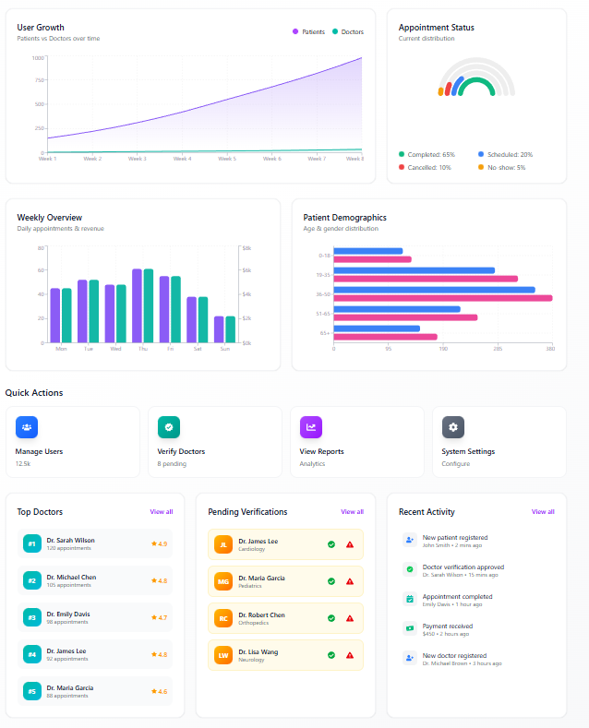

*Figure 7.48: Admin Dashboard - Detailed Analytics*

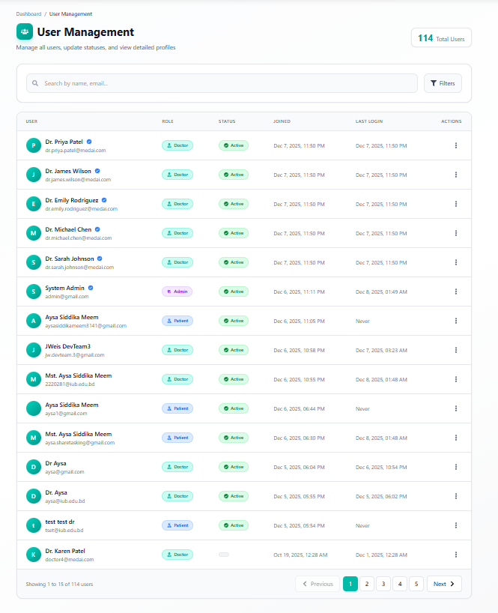

*Figure 7.49: User Management Page*

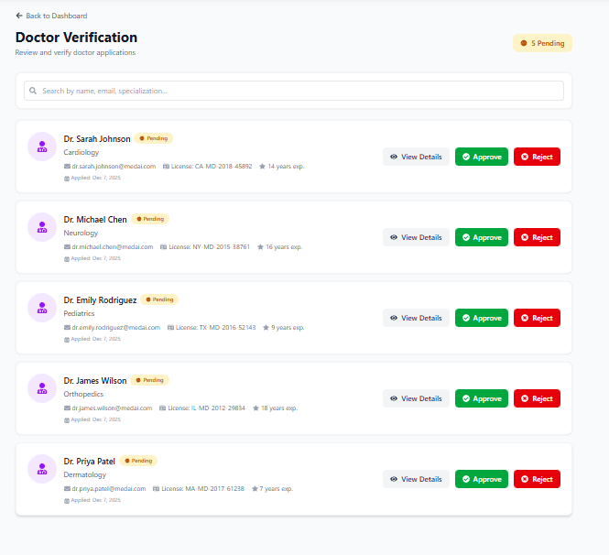

*Figure 7.50: Doctor Verification - Pending Applications*

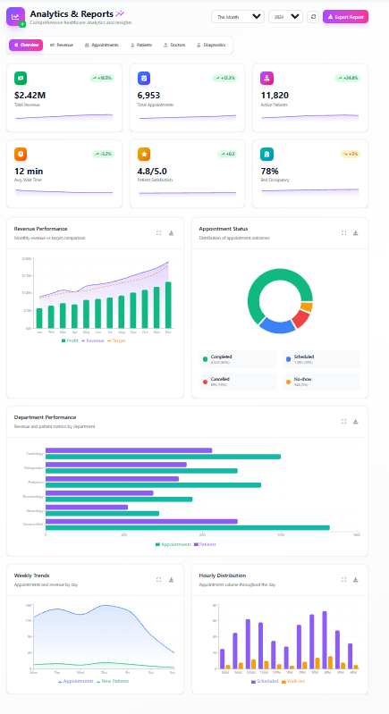

*Figure 7.51: Doctor Verification - Document Review*

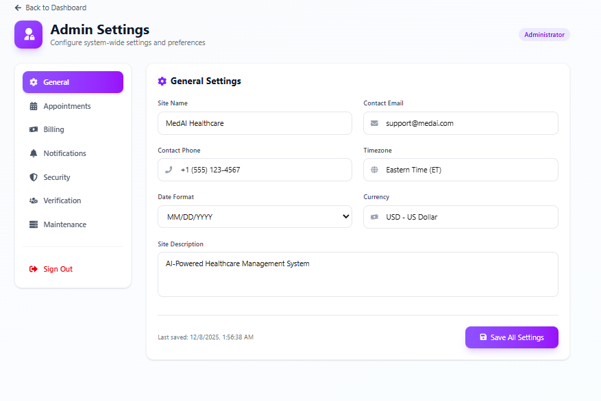

*Figure 7.52: Admin Settings - General Configuration*

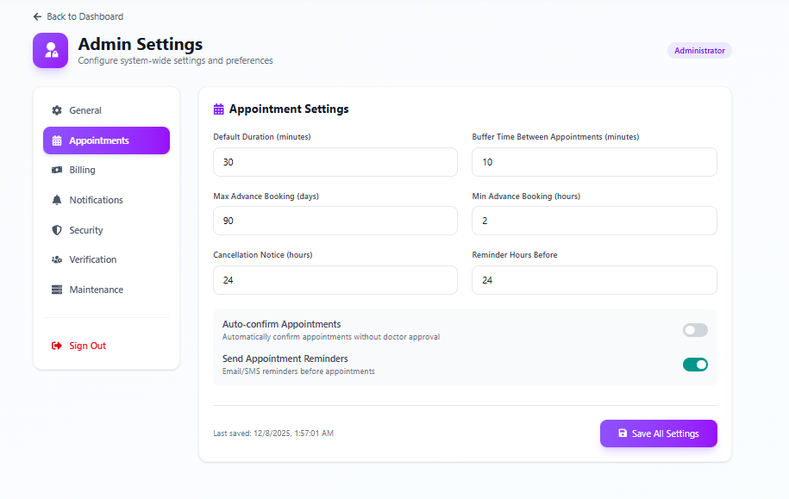

*Figure 7.53: Admin Settings - Email Configuration*

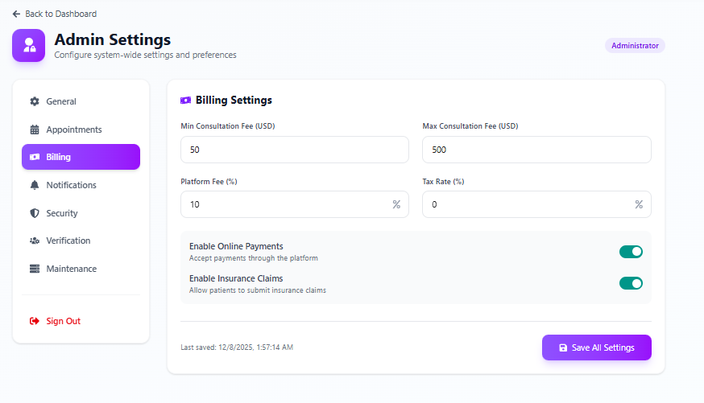

*Figure 7.54: Admin Settings - Notification Settings*

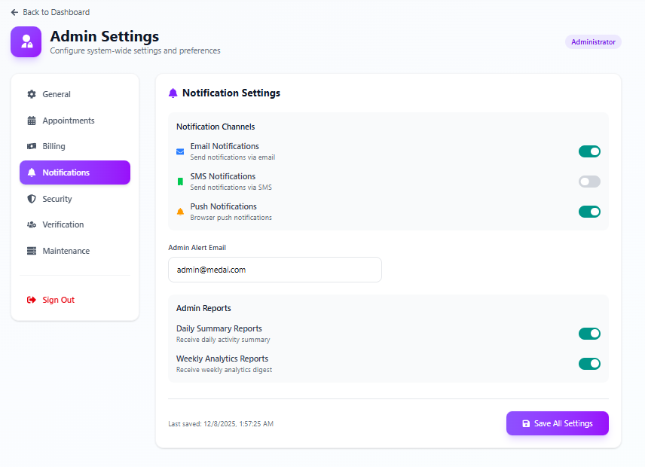

*Figure 7.55: Admin Settings - Security Settings*

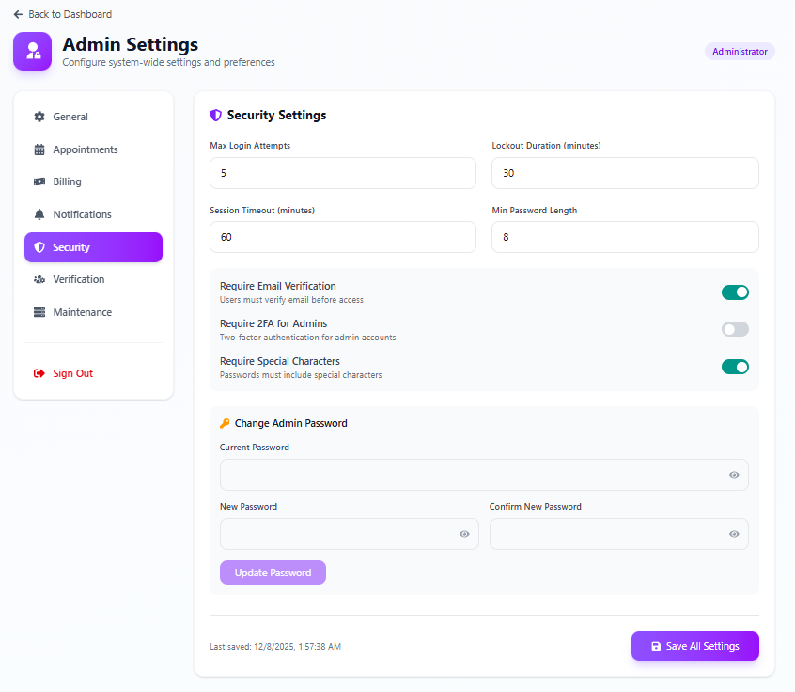

*Figure 7.56: Admin Settings - Payment Gateway*

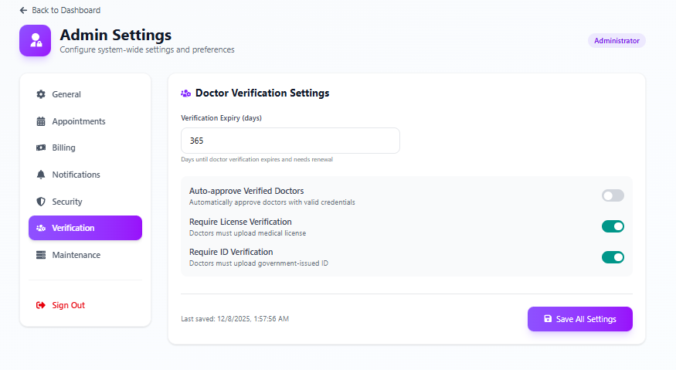

*Figure 7.57: Admin Settings - Backup Configuration*

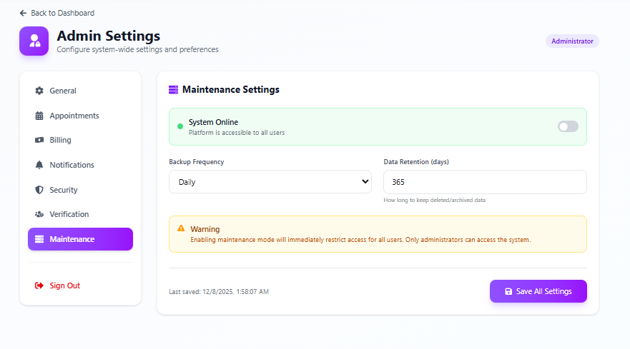

*Figure 7.58: Admin Settings - System Maintenance*

## 7.1 Result Analysis

The input and output design of the AI-Enhanced Healthcare and Wellness Management System demonstrates a comprehensive approach to user interface development. The system successfully implements intuitive input forms with proper validation and user-friendly output displays with clear information hierarchy. Key achievements include responsive design across all modules, consistent visual language, and seamless navigation between features. The AI-powered components (Symptom Checker, Health Prediction, Chatbot) provide intelligent outputs that enhance the overall healthcare experience. The multi-role dashboard design effectively caters to the distinct needs of patients, doctors, and administrators while maintaining system coherence and security.